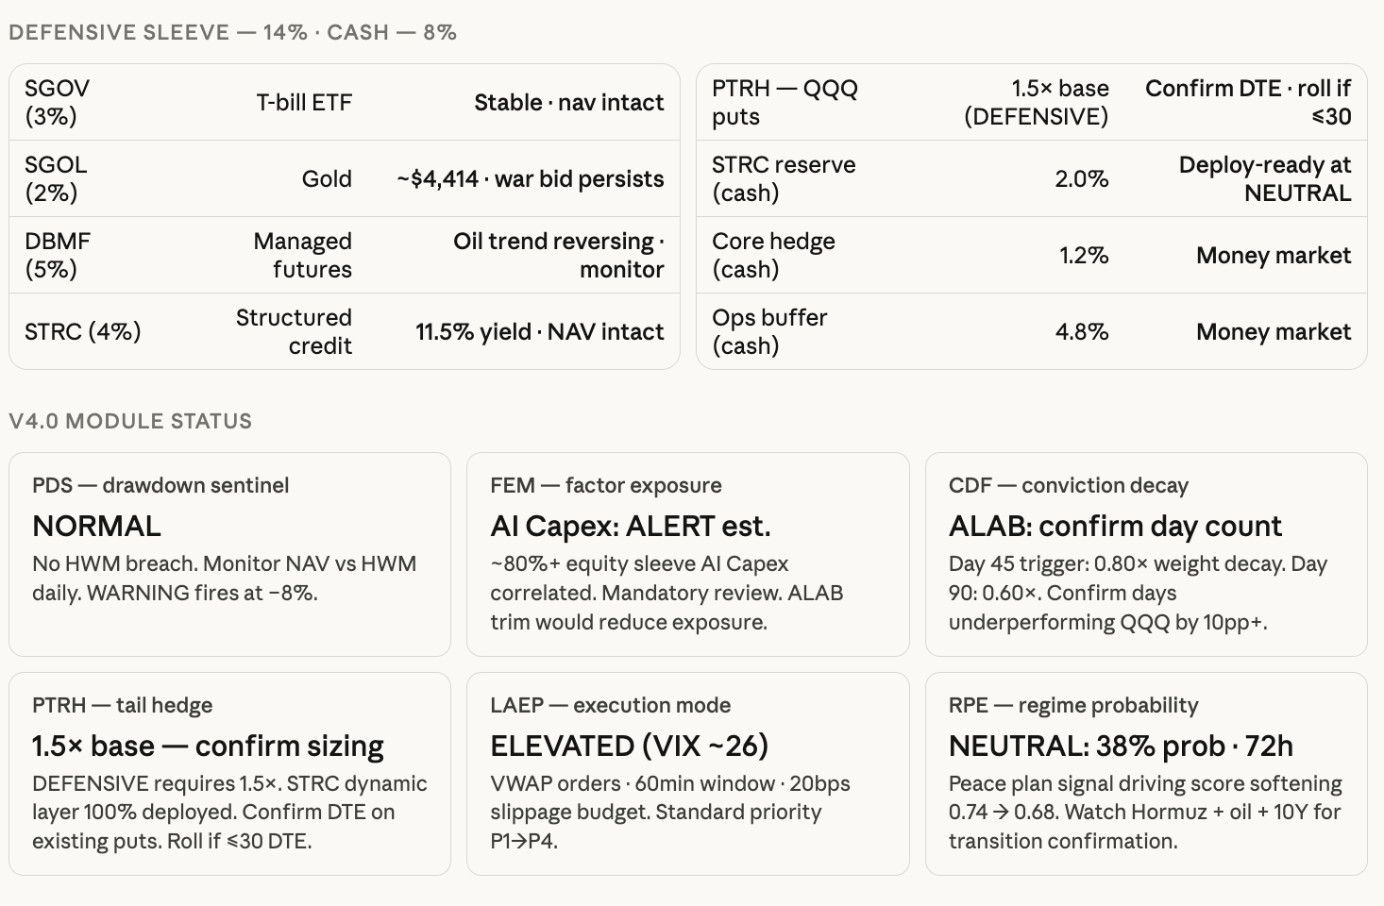
DEFENSIVE SLEEVE - 14% CASH - 8%
SGOV
PTRH-QQQ
T-bill ETF
Stable nav intact
(3%)
SGOL (2%)
puts
1.5x base (DEFENSIVE)
Confirm DTE ⚫ roll if
≤30
STRC reserve
Deploy-ready at
Gold
~$4,414. war bid persists
2.0%
(cash)
NEUTRAL
DBMF
(5%)
Managed futures
Oil trend reversing. monitor
Core hedge (cash)
1.2%
Money market
STRC (4%)
Structured credit
11.5% yield. NAV intact
Ops buffer (cash)
4.8%
Money market
V4.0 MODULE STATUS
PDS- drawdown sentinel
NORMAL
No HWM breach. Monitor NAV vs HWM daily. WARNING fires at -8%.
PTRH-tail hedge
1.5x base-confirm sizing DEFENSIVE requires 1.5x. STRC dynamic layer 100% deployed. Confirm DTE on existing puts. Roll if <30 DTE.
FEM-factor exposure
Al Capex: ALERT est. ~80%+ equity sleeve Al Capex correlated. Mandatory review. ALAB trim would reduce exposure.
LAEP -execution mode
ELEVATED (VIX ~26)
VWAP orders. 60min window 20bps slippage budget. Standard priority P1⇒P4.
CDF conviction decay
ALAB: confirm day count
Day 45 trigger: 0.80x weight decay. Day 90: 0.60x. Confirm days
underperforming QQQ by 10pp+.
RPE - regime probability
NEUTRAL: 38% prob. 72h
Peace plan signal driving score softening 0.74 0.68. Watch Hormuz + oil + 10Y for transition confirmation.

